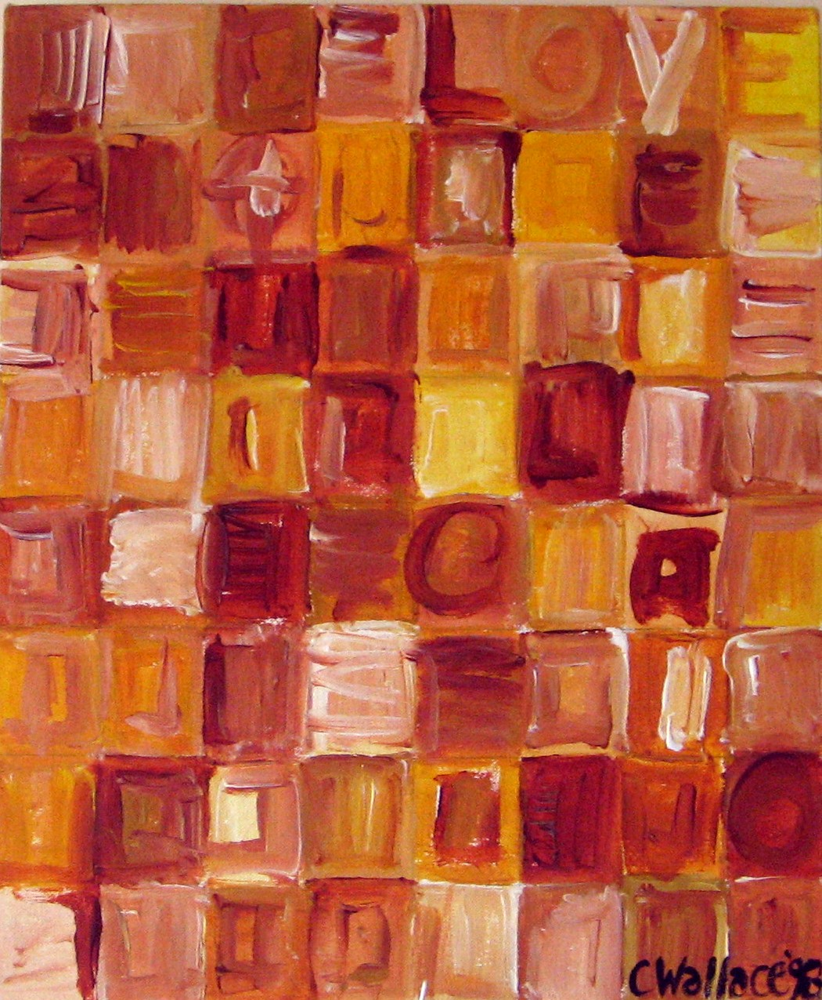
DJ CS Wallace
Choice: A Collection Of Classics 4 - Soulful House Special

DJ CS Wallace
Soulful House Special

The Ambassadors Of Swing – Coming Up
Julie Mcknight – Home
Deep Sensation – Soul Heaven
Kenny Bobien – Dance
Dawn Tallman – Work It Out
Reality Check – Fantasy
Head Rush – Underground
Farley & Heller – Ultra Flava
Christian Falk – Make It Right
Tawanna – In My World
Michael Proctor – Fall Down
Luther Vandross – Are You Using Me?

Artwork By DJ CS Wallace: ‘Yellow’ from the ‘Love’ Series, 1998

